TPD and T-Crate Test Procedures for ESS-Tests

Table of Contents
Table of Contents 2
Scope 3
The AMS TPD and T-Crate 3
General Test Philosophy 3
Generic Test Setup for TPD and T-Crate tests 3
Block diagram for TPD together with GSE 3
Block diagram for TPD with T-Crate 4
Functional Tests 4
Long Functional Test 4
Fast Functional Test 4
Continuous Running 4
Thermal Cycling Test 4
Temperature Requirements 4
Thermal profile 5
Functional test procedure 5
Vibration Test 7
Stress Requirement 7
Functional Test procedure 7

Scope
In this document we describe the test procedures for the ESS-Test of TPD and T-Crate at CSIST in July 2005:
- Thermal cycling test
- Vibration test
The EMI Test and Thermal Vacuum Test (TVT) will be described in a separate document.

The AMS TPD and T-Crate
See a description elsewhere…

General Test Philosophy
During the tests, the TPD and T-Crate will be treated as a unit and always read out together, even if during vibration only one of the 2 crates is the Device under Test (DuT). To guarantee a full functionality test of the TPD, a special ground support equipment (GSE) with according Labview software has been prepared by INFN Perugia. The GSE will be used before the first test in the thermal chamber, to also check extended features of the TPD like recovery after short-circuits etc., and again after finishing the vibration and the second test in the thermal chamber. The T-Crate will be tested before the first test and after the last test with a dry-run of the test-procedures in the lab.

Also, for the tests, we follow the same strategy as in previous performed tests, like described e.g. in the JT-Crate Test Report, by C.H. Lin. We also take-over the same temperature profiles and vibration requirements as in the above report.

Generic Test Setup for TPD and T-Crate tests

Block diagram for TPD together with GSE

28 V
power supply

Ground Support Equipment

3.3 V
power supply

TPD

Power

± 12 V
power supply

Lecroy
…
PC with Labview
5.5 V
power supply

Labview

Block diagram for TPD with T-Crate

TPD

T-Crate

EPPCan

Power

AMSwire & Trigger
(to JINF, 4+1 lines)
Parallel Port
Lecroy

Power 28 V

(redundant)
PC with Control Software

28 V
power supply

The DuT can be either the TPD, or the T-Crate (for the vibration tests) or both (in the thermal chamber)

Functional Tests

Long Functional Test
The long functional test consists of the following procedures:
- Test of SlowControl Functionality (see detailed document)
  - Test of S9011AT
  - Test of the 2 TBS
  - Test of the 4 TPSFE
- Test of Data Acquisition (see detailed document)
  - Test of JINF
  - Test of TDR

Fast Functional Test
The fast functional test contains a reduced set of the above functions, verifying basic functionality, but not in all possible combinations. This test is used for the short time periods on the vibration table.

Continuous Running
After the long functional test, we run the system continuously, switching between data taking and calibration mode.

Thermal Cycling Test

Temperature Requirements
- Hot non-operating phase: +85^{O}.
- Hot operating phase: +55 ^{O}.
- Cold operating phase: -25 ^{O}.
- Cold non-operating phase: -45 ^{O}.

Thermal profile
The thermal profiles are shown in Figure 1 and Figure 2. There are 10 cycles before the vibration test and five cycles after the vibration. The functional tests are performed at 1st, 5th, 9th and 10th cycle before vibration, and at 11th, 14th and 15th cycles after vibration.

Functional test procedure
- Wait until the temperature is stable (~ 1 hour)
- Power on 28 Volt
- Follow the long functional test procedure (~ 30 minutes)
- Run the system continuously in readout/calibration (~ 1 hour)
- Repeat the long functional test procedure (~ 30 minutes)
- Power off

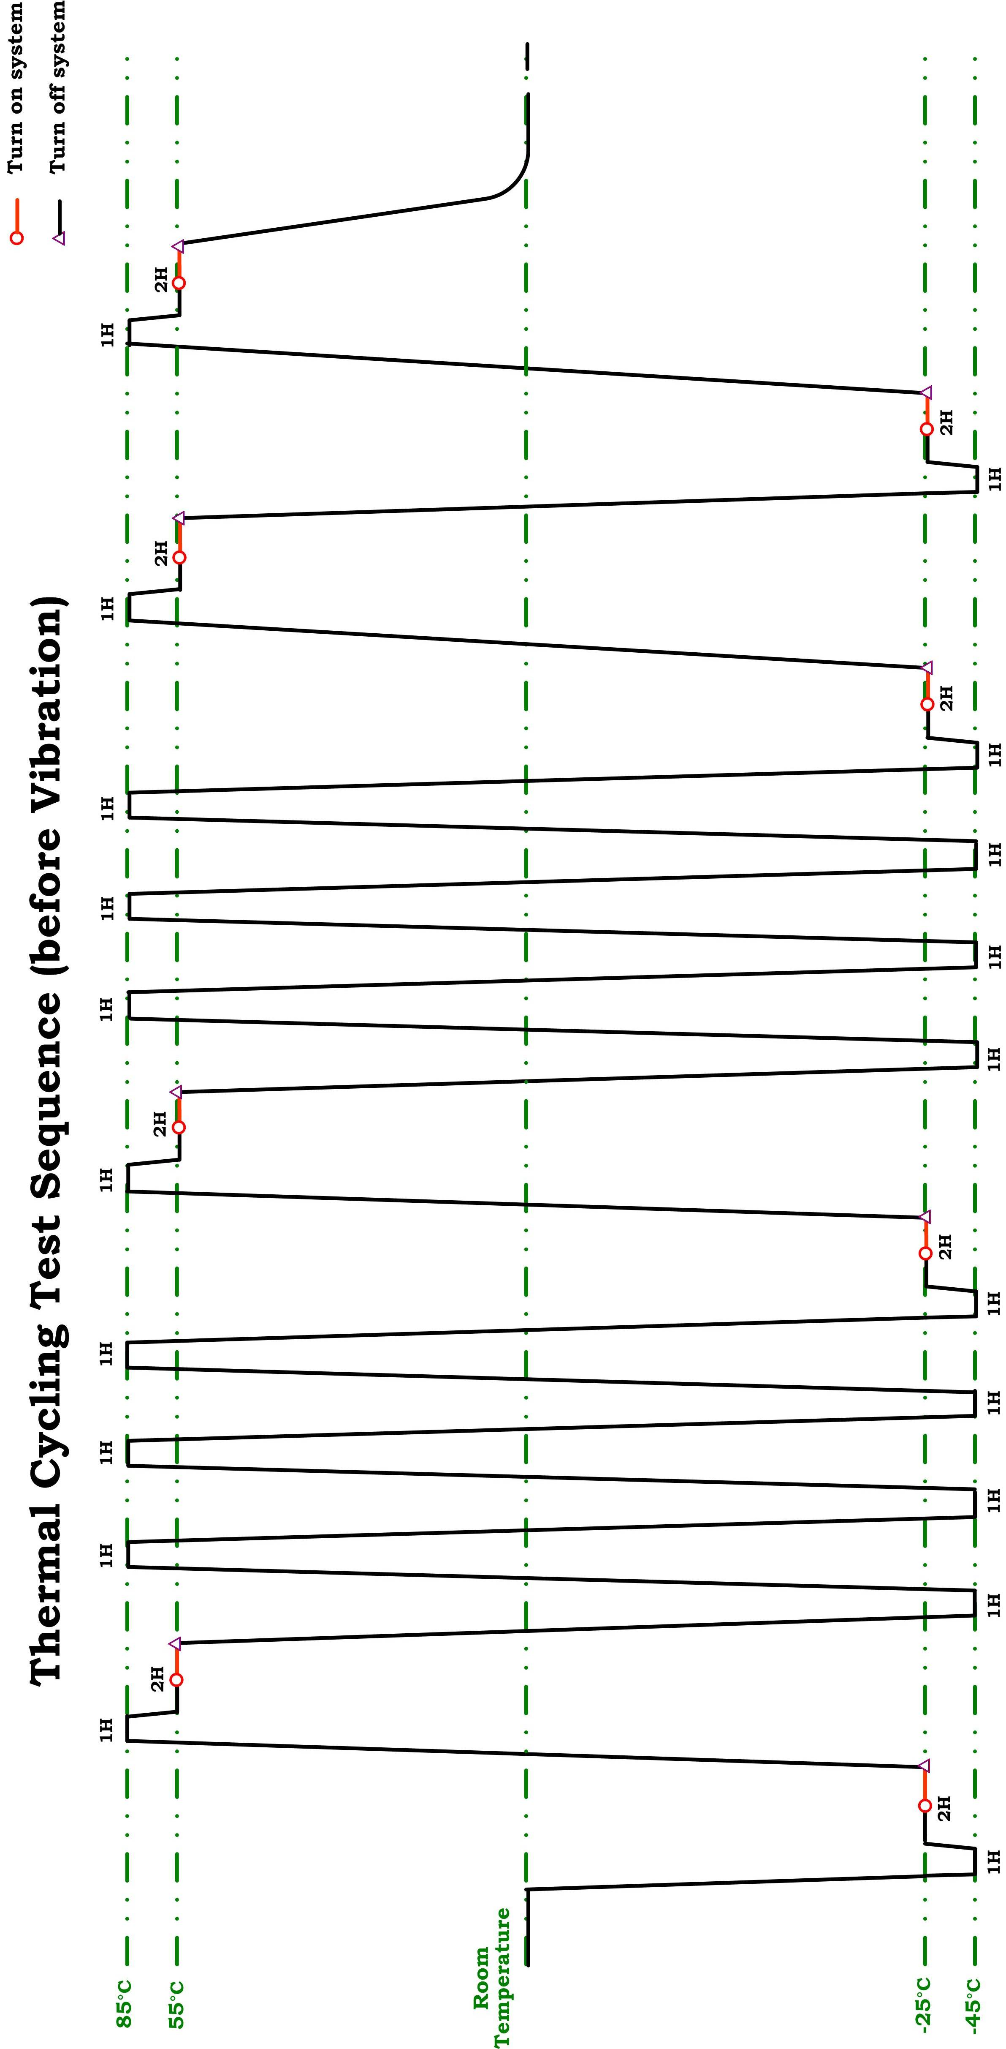
Figure 1: The thermal cycling test profile before the vibration test.

Figure 1: The thermal cycling test profile before the vibration test.
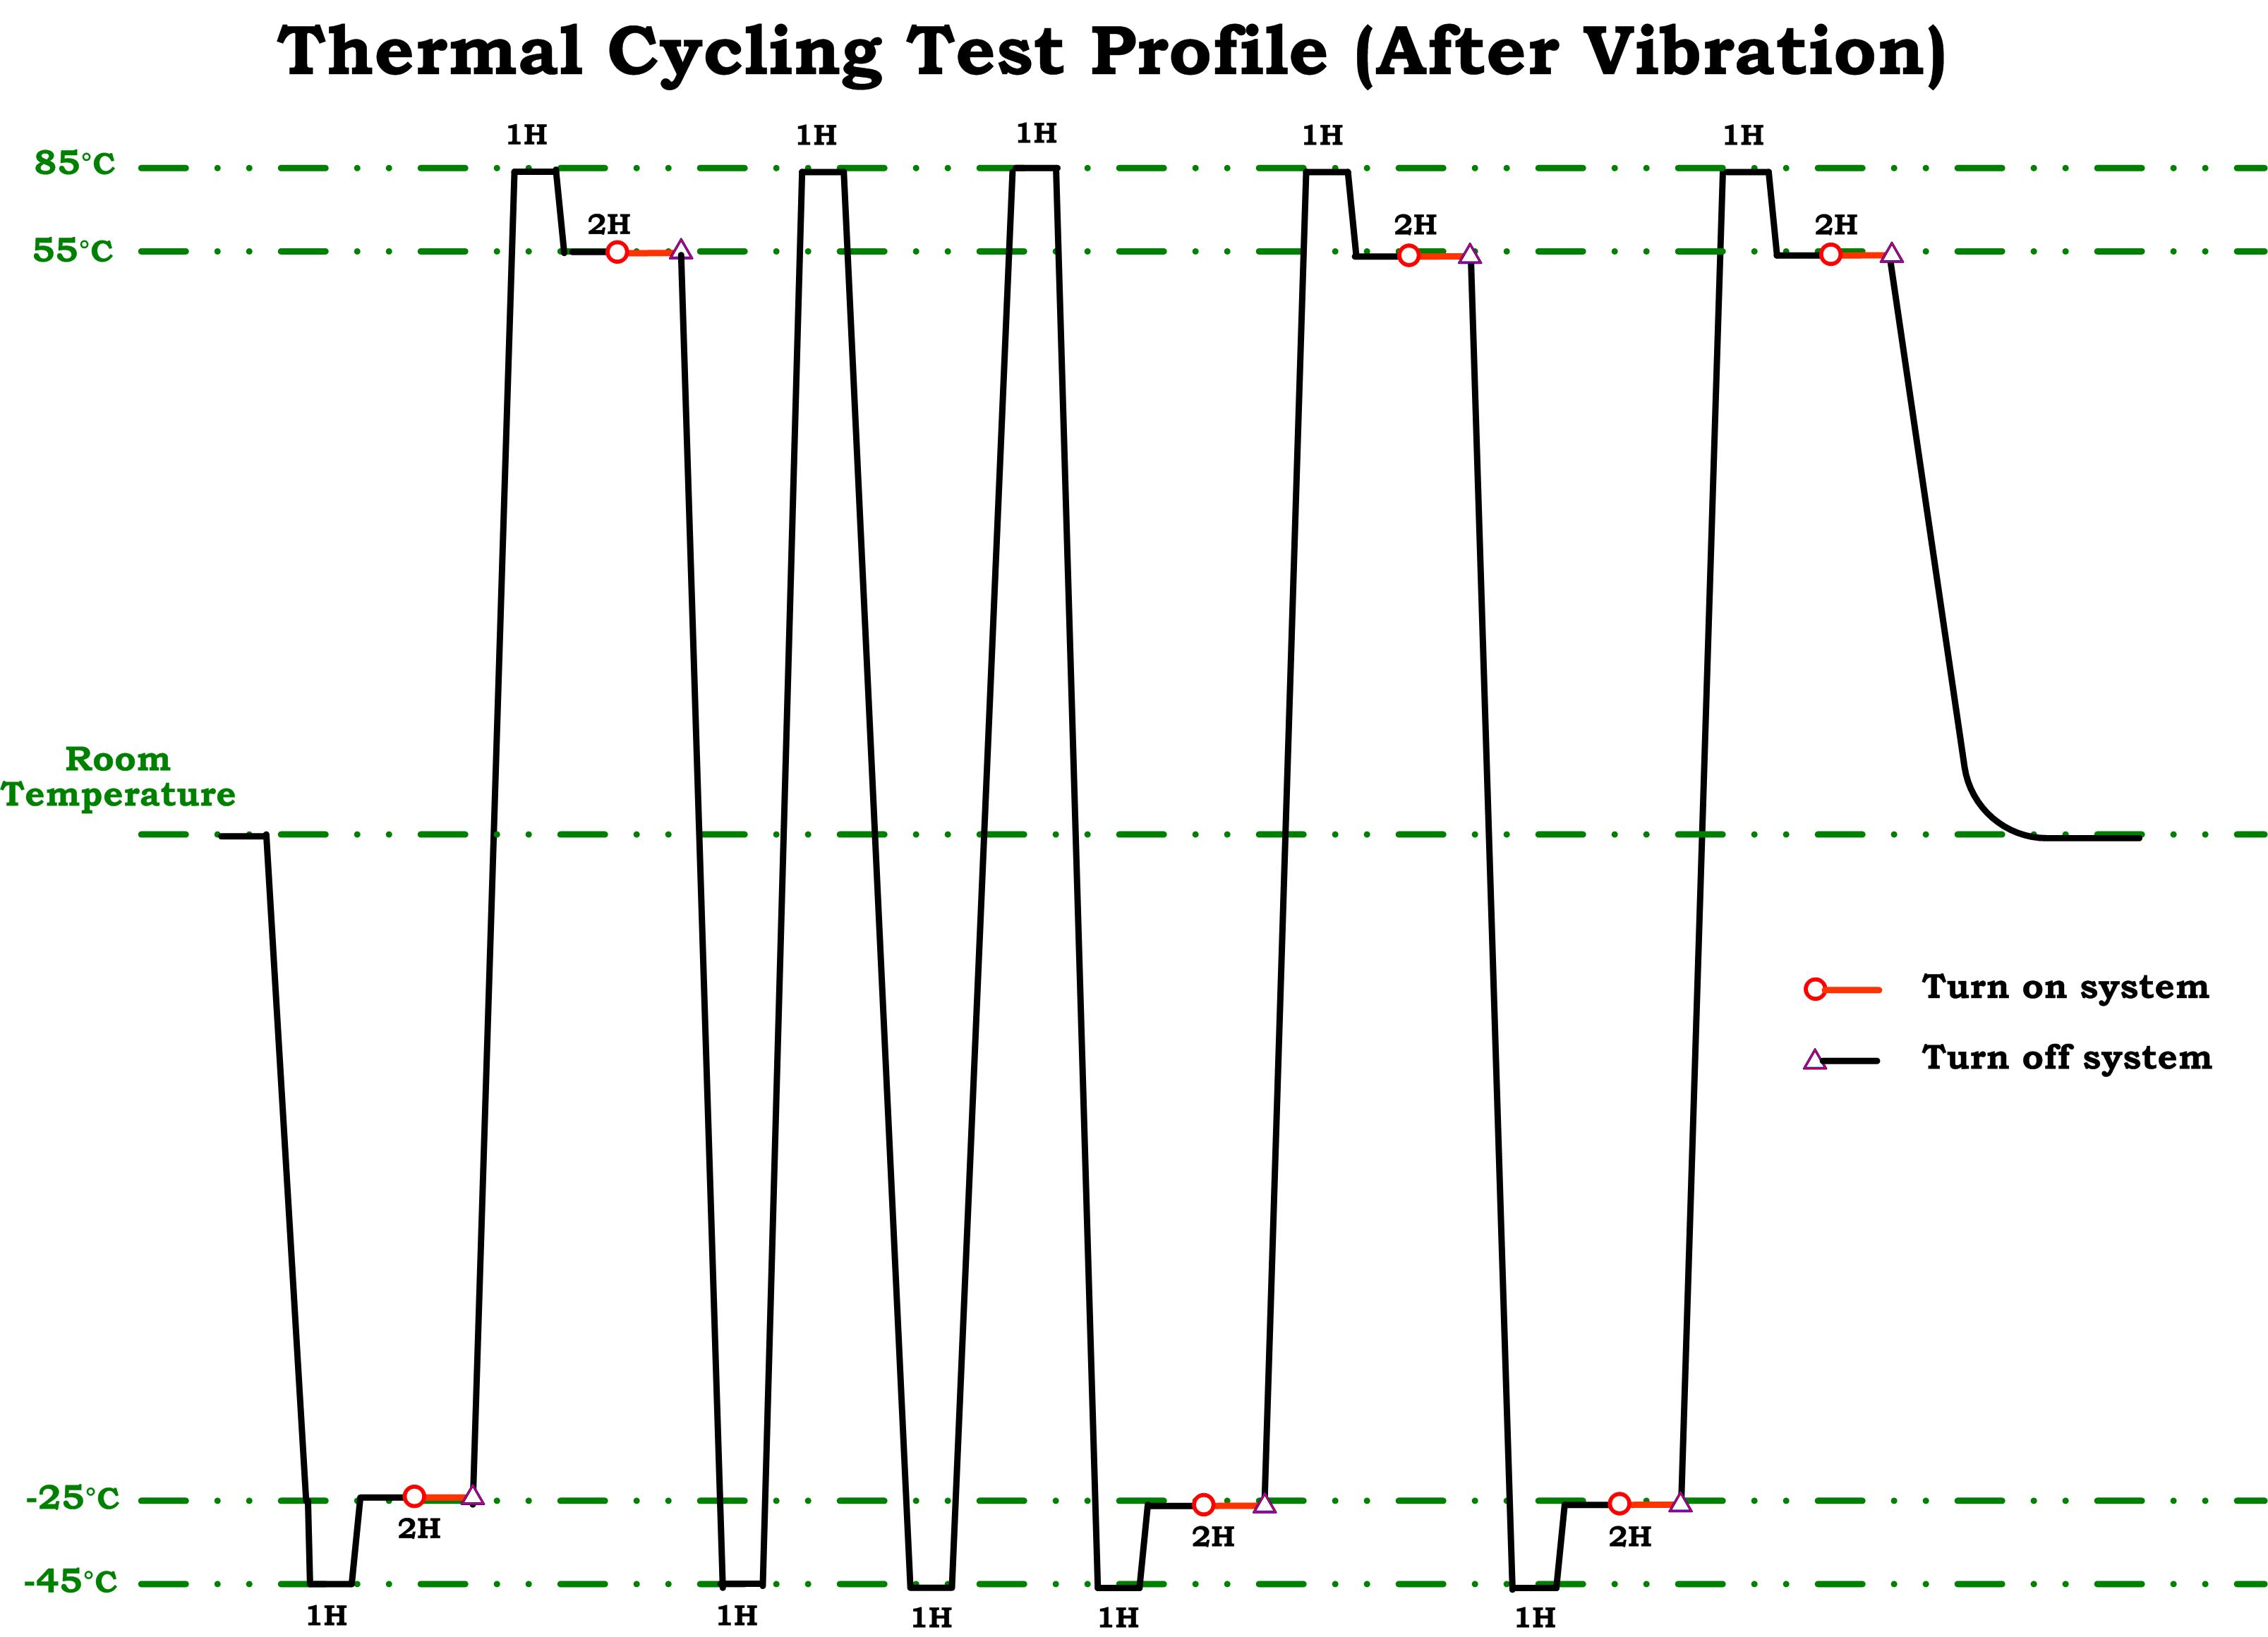
Figure 2: The thermal cycling test profile after the vibration test.

Vibration Test

Stress Requirement
- Sine wave sweeping test shall follow the NASA document 740-SPEC-008.
- Random vibration test shall follow the NASA document NASA-STD-7001.
- Vibration direction: X, Y and Z directions.
- Duration: 10 minutes for each direction.

Functional Test procedure
Only one of the 2 crates is the DuT, the test procedure is identical for both crates. After the test of the TPD, the crates will be swapped and the same test is again for the T-Crate.
- Power on 28 V
- Follow the fast test procedure (< 10 minutes)
- Repeat this procedure for all 3 directions of vibration
- Power off

