Hybrid Assembly – Proposal for Sequences
ID | Operation | Pictures
0 | Ensure that the pre-assembly of the sensor to baseboard is on the right jig (sensor to baseboard assembly jig) | Pict ID 1120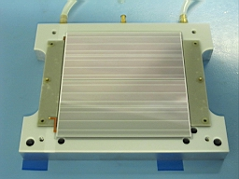
1 | Locate the “T” aluminum piece (central bar) on the assembly jig thanks to the 2 baseboard central pins | Pict ID 1121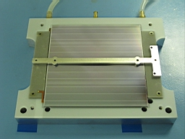
2 | Get the 1st hybrid out from the protection box | Pict ID 1124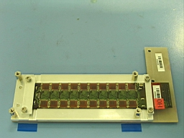
3 | Move the hybrid up-side-down to the plastic jig. Hybrid is located inside grooves but is not maintained! | Pict ID 1126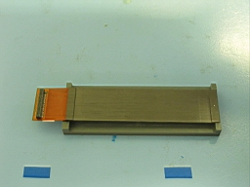
4 | Spray the glue standard Araldit or loaded with boron with a small spatula on the hybrid feet. Please avoid having glue on the inside of the hybrid. | Pict ID 1145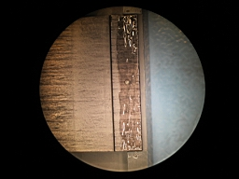
5 | Install the hybrid onto the module baseboard and against one side of the “T” piece close to the final position. Please identify the hybrid ID versus the location. | Pict ID 1127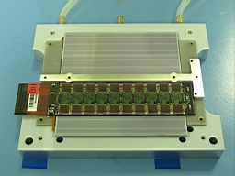
6 | Repeat operation 2, 3, 4 and 5 for the 2nd hybrid. | Pict ID 1128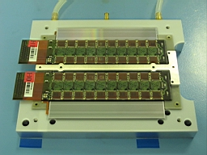
7 | Look under a binocular and be sure that each hybrid is pushed against the 3 location points: 2 in the silicon region and 1 on the side of the “T”. | Pict IDs: 1148 & 1146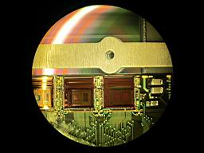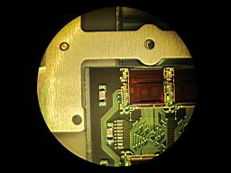
8 | Take the 1st aluminum bridge with 6 screws and 2 Peek cams. The Peek cams must be released and the 6 screws moved up! Install them on the baseboard assembly jig on the opposite side of the pigtail and fix it with the 2 side screws. | Pict ID 1129 right part  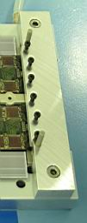
9 | Take the 2nd aluminum bridge with 4 screws and 2 Peek cams. The Peek cams must be released and the 4 screws moved up! Install it on the baseboard assembly jig on the pigtail side and fix it with the 2 side screws. | Pict ID 1129 left part  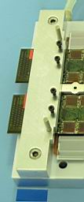
10 | Turn the two Peek cams together very gently such that each hybrid is pushed against the “T” central bar.  Bottom hybrid on the picture turn the Peek cams clock wise and for the top one anti-clock wise. | Pict ID 1129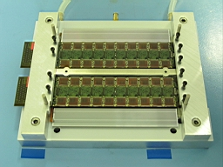
11 | Tighten the black screws (10 in total) such that the hybrid feet are pressed against the ceramic facings.  NB:  - Note that the extremity of the black screws must have a plastic head. If not the hybrid could be destroy with some uncontrolled force!  - The torque for the screws must be controlled and kept low. If done by hand tightening must be gentle.
12 | Leave 24 hours for curing
13 | Remove all the jigs above by releasing first the Peek cams and then the 10 screws. One the 2 bridges are remove please remove the “T” central bar. | Pict ID 1138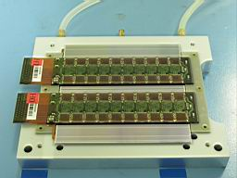
14 | Turn the module up-side-down on another dedicated jig with the foot print of the 1st two hybrids already glued on the other side. | Pict ID 1139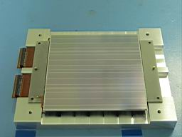
15 | Proceed with the same operation above: 1 to 13 | Pict ID 1154